Set 2

1. import matplotlib.pyplot as plt
import numpy as np

x = np.array(["cricket", "foodball", "hocky", "badminten","swimming","tennies"])
y = np.array([80, 40, 20,30,45,75])
plt.title("favourite sports")
plt.xlabel("sports")
plt.ylabel("no.of students")

plt.bar(x, y,color = "red", width =.2)
plt.show()

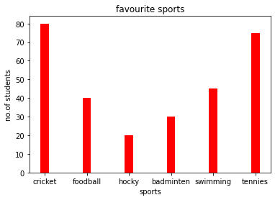

2.def repeat_times(n):
s = 0
n_str = str(n)
while (n > 0):
n -= sum([int(i) for i in list(n_str)])
n_str = list(str(n))
s += 1
return s
print(repeat_times(5))
print(repeat_times(10))
